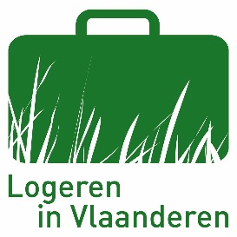
MESSAGE FOR GUESTS AT THE HOLIDAY HOME
The holiday home was cleaned and sanitised prior to your arrival in accordance with the government guidance on cleaning to prevent the spread of the COVID-19 virus.

We kindly ask for your cooperation in keeping the home clean and Covid secure.

To that end may we please draw your attention to the following points:

1/ Our expectation of the guest (s):
- Wash your hands regularly.
- A cough or sneeze? Use a paper handkerchief and then dispose of it immediately in the bin provided.
- Whenever you leave (your room) respect the 1.5 metre distancing rule. If distancing is not possible use face masks (compulsory on the bus, tram and train).
- Avoid physical contact with anyone other than your travel companions.
- Avoid cash and use bank transfers/ bancontact electronic payment/…

2/ In the home
  - Ventilate all areas of the home regularly and fully.
  - Go around the home once a day to clean and sanitise the most frequently touched areas, such as:
- light switches
- door handles
- drawer handles
- bathroom fittings
- taps
- work surfaces and kitchen sinks
- remote controls, etc.

To enable you to do this we will give you a new sponge, dish cloth, floor cloth, kitchen roll and sanitizer when you arrive.

You can contact us by phone at any time if you have a question.

Your stay will be safe and secure, provided we all follow the guidance.

We know we can count on your cooperation!
Enjoy your holiday!

The proprietor(s)

